Sales Forecasting with Salesforce Sales Cloud

How To Use Salesforce Sales Cloud for Accurate Sales Forecasting, Including Setting Up Forecasting Models and Analysing Sales Data

Sales forecasting is a critical component of sales management. Businesses may anticipate future sales with the help of the forecasting methods provided, making proactive decisions to achieve the set objectives.
This article delves into the usage of Salesforce Sales Cloud in precise sales forecasting, dissecting, setting up forecasting models, and analysing sales data. Salesforce shall enable businesses to improve their forecasting process to drive revenue growth and business success effectively.

Sales Forecasting with Salesforce Sales Cloud: Overview

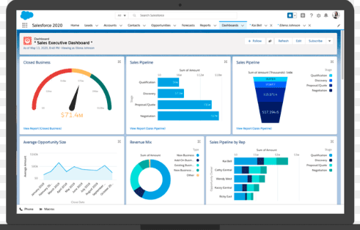
Businesses rely on sales forecasts. In order to make wise planning, they show prospective revenues. Sales Cloud by Salesforce is an excellent platform for managing customers. Impressive tools are available for making precise sales predictions.

Sales teams can use these to track sales patterns in the future. They can then make better use of their resources and increase their income. The platform has a central repository for all sales data, leads, opportunities, and deals, so sales teams can quickly obtain and analyse the crucial data they require.

Businesses can use Salesforce's forecasting feature to examine historical sales data, present market conditions, and critical details to accurately anticipate future sales performance. The robust analytics and reporting capabilities of Salesforce Sales Cloud set it apart. Customisable visualisations and thorough reports are available to users.

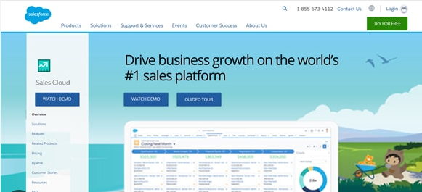

These display sales figures as they happen. You may learn a lot about sales performance from this. Sales pipeline velocity, win rates, and conversion rates are some of the key performance indicators (KPIs) that managers keep tabs on. They have an eye for improvement and can see patterns.

Advanced forecasting capabilities are also provided by the platform. Predictive analytics and models for making predictions are at your disposal. With these, businesses can develop sales forecasts with better precision.

Their operation is based on the application of machine learning to analyse previous data. Accurate sales forecasting is made possible by this. Decisions and resource allocation can be improved.

Salesforce Sales Cloud makes working together easier. Effortlessly share projections, insights, and practices with your sales team. Managing people entails setting goals and quotas and monitoring progress towards those objectives. This fosters accountability and alignment in sales teams.

In short, firms may gain the necessary skills and expertise through sales forecasting with Salesforce Cloud. It aids in forecasting sales patterns, allowing firms to distribute resources efficiently and propelling revenue growth.

Wise use of the many features and capabilities offered by the Cloud allows businesses to make well-informed decisions and strategies. Even in today's cutthroat marketplaces, they manage to meet and exceed sales goals.

Optimizing Sales Forecasting with Salesforce Sales Cloud

There are several essential procedures and best practices to follow when using Salesforce Sales Cloud to generate reliable sales forecasts:

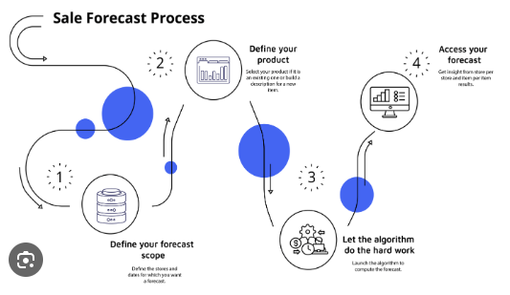

Data Quality Management

Make sure and Verify that Salesforce contains accurate data as part of data quality management. Accurately document and maintain records of all leads, deals, accounts, and contacts. Enforce validation policies, making sure that the records entered into Salesforce meets unique criteria, Use data integration tools to synchronize Salesforce with other databases or systems, ensuring data consistency across platforms.

Define Forecast Categories

The second step is to define the forecast categories, which should be tailored to your sales procedure. Use the factors that correspond to the various stages of your agreements to identify fresh sales opportunities. Create custom fields to capture specific data points, Define clear sales stages that align with your sales funnel, from prospecting to closure.

Establish Sales Processes

Ensure Salesforce has clear sales procedures. Incorporate lead qualification criteria, transaction stages, and sales methodologies. The accuracy and consistency of sales forecasts depend on the sales team's ability to standardise.

Opportunity Management

Fourth, manage opportunities by enforcing a commitment from your sales staff to update Salesforce with new information regularly. Rigorously document critical information such as deal size, closing dates, probabilities, and revenue potentials.

These records should accurately reflect the opportunity's progress, which is why regular reviews are necessary.

Use Forecasting Tools

Use Salesforce's customisable reports, dashboards, categories, and built-in forecasting features to precisely forecast future sales, analyse previous performance, and spot trends.

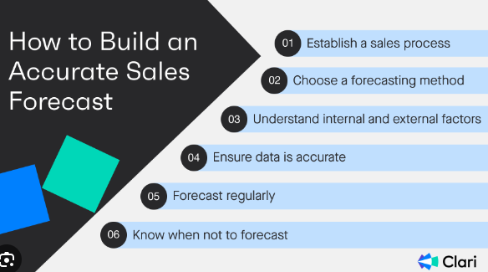

Utilize AI and Predictive Analytics

These tools provide a thorough understanding. Salesforce's artificial intelligence (AI) powerhouses, Einstein Analytics and Einstein Forecasting, enable well-informed decision-making by uncovering patterns in previous data and receiving predictive forecasts. Furthermore, AI-powered insights enhance forecasting accuracy and strategic planning. enables proactive decision-making and trend identity.

Collaboration and Feedback

Have everyone examine the prediction information frequently to foster cooperation. Improve your forecasting and sales by having an open dialogue, sharing ideas, and receiving feedback.

Continuous Monitoring and Adjustments

Keep an eye on the difference between predicted and actual sales as you make adjustments in step eight. Establish KPIs and metrics to monitor forecast accuracy, sales performance, and pipeline health. frequently review and regulate forecasting models primarily based on actual performance, market dynamics, and emerging developments. Look for discrepancies and identify reasons. Take this knowledge and apply it to your forecasting techniques for better outcomes.

Implementing these best practices and using Salesforce Sales Cloud's powerful tools can improve your forecasting, decision-making, and overall success.

Configuring Forecasting Models in Salesforce Sales Cloud

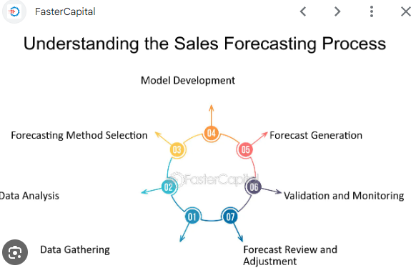

Salesforce Sales Cloud has a multi-step approach for setting up forecasting models. You can tailor the forecasting to fit the specific requirements of your organisation. These are the steps to follow:

Define Forecasting Categories

These categories should correspond to the various stages of the sales cycle and be in line with your procedure. Selected examples include pipeline, closed win, best case, and committed situations.

Configure The Forecast Types

Two, several kinds of forecasts are set up: opportunity-based and product family forecasting, which are only two of the many options available in Salesforce. Choose the one that works best with your company's structure and how you handle sales.

Customize forecasting periods

Set the intervals for when you want forecasts generated: monthly, quarterly, or yearly. Adjust them so they align with the reporting and planning periods that you use.

Set Forecasting Quotas

Assign Forecasting Capacity: Based on historical performance, current market conditions, and company objectives, set sales quotas for each team. Allocate quotas according to the categories and periods used for forecasting.

Make a Strategy for Sales Forecasting

Decide how you'll organise your sales forecasts, whether by salesperson, region, or product category. To ensure everything is visible to everyone, decide who can view what.

Adjust Forecasts Wisely

Whilst setting up forecasts, construct in flexibility to allow sales managers to make modifications based totally on converting market situations, unexpected challenges, or possibilities.
Leave room for sales managers to make adjustments to projections in light of current market conditions. To ensure that changes maintain accurate forecasts, provide them with defined rules.

Make Use of CRM Data

Incorporate Salesforce CRM information to guarantee accurate sales forecasts. Leverage Salesforce CRM records, consisting of customer profiles, sales records, and pipeline information, to inform your forecasting models.
Perform data analysis and make use of advanced analytics tools to analyse ancient records, become aware of trends, and forecast future income primarily based on CRM records insights.

Educate Your Staff

Instruct your staff to use the forecasting tools appropriately. Give an example of how and why accurate prediction is critical for sound decision-making. Offer real- life examples illustrating the effect of accurate forecasting on business decisions, revenue increase, and customer satisfaction.

Maintain Vigilance

Monitor the situation closely to see if our forecasts align with reality. We will improve our models over time by fixing any mistakes we find.

When we do these things in Salesforce, it improves our decision-making, which in turn helps our business flourish.

Analysing Sales Data in Salesforce Sales Cloud

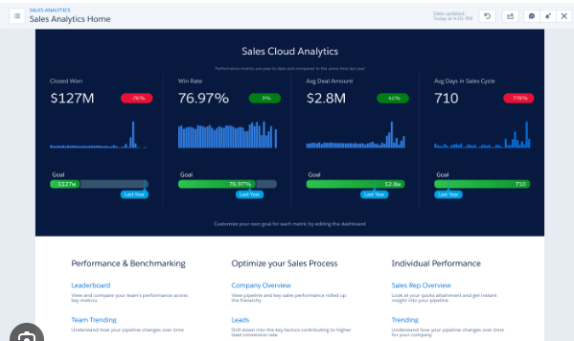

If you want to know how your sales are doing, identify trends, and make informed decisions, you need to analyse your sales data on Salesforce Sales Cloud. The way to do it is as follows:

Data Accuracy and Organization

Make sure that the Salesforce database is accurate, well-organised, and comprehensive. It is essential that all data pertaining to sales activity, accounts, contacts, opportunities, and leads be available.

Make Custom Reports

Second, bespoke reports can be created by utilising Salesforce's reporting features. You can customise, add filters, and arrange criteria according to your requirements, such as the salesperson, area, product, or time you wish to view.

Build Dashboards

Use Salesforce to design dashboards that display all sales data visually and facilitate ease of use. Sales trends and other critical information can be displayed using charts, graphs, and tables.

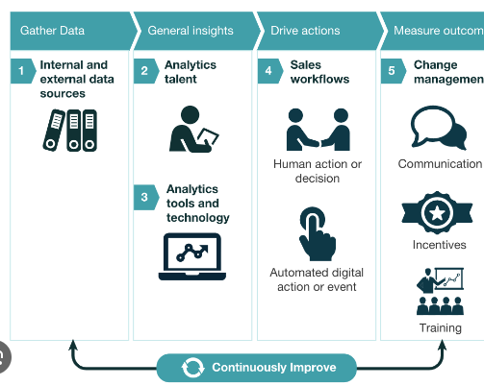

Sales Performance Metrics

Keep an eye on metrics like win rate, deal size, sales cycle length, and quota achievement as they pertain to sales performance. Evaluate progress in relation to predetermined standards of excellence and establish objectives for continuous improvement.

Sales Forecasting and Predictive Analytics

Use Salesforce's forecasting capabilities and predictive analytics to anticipate sales performance in the future and assess risks and opportunities. Analyse sales history to make better, more informed business decisions based on data.

Analysing Performance of Individual Sales Reps

Assess each sales representative's performance to identify high achievers, areas for improvement, and potential coaching opportunities. Track the sales team's actions, conversions, and results to guarantee efficient production.

Integration with External Data Sources

To obtain a more comprehensive understanding of the customer experience and sales ecosystem, integrate Salesforce Sales Cloud with additional data sources, including customer support tools, ERP systems, and marketing automation platforms.

Considering this in context, organisations may achieve growth and better decision-making by gaining useful insights into their sales performance with Salesforce Sales Cloud.

Final Thoughts

With Salesforce Sales Cloud's extensive set of tools and services, companies can rest assured that their sales forecasts will be spot on. The forecasting process can be adjusted to align with an organisation's sales process and objectives through the customisation of forecasting models.

Organisations can learn more about the efficacy of their sales performance and identify trends by analysing sales data in Salesforce.

In addition, by making good use of Salesforce Sales Cloud for sales forecasting, businesses can optimise sales tactics, allocate resources more effectively, and drive growth in today's competitive market. Data-driven decisions are the result.

